The following device label (Figure 1) (designed according to requirements set out in Section 86 of the Medical Devices Regulations) will be included in the Operator's Manual, product monograph and will be affixed to the outer packaging of each investigational device. A similar label (Figure 2) containing identical elements (device name, manufacturer name, investigational statement) along with a unique investigational device code will be affixed directly to each device. See Appendix for Device Label file.

Glia Inc. Pulse Oximeter
INVESTIGATIONAL DEVICE  To be Used by Qualified Investigators Only | INSTRUMENT DE RECHERCHÉ  Réservé uniquement à l'usage de chercheurs compétents

Figure 1. Device Label for Operator's Manual, product monograph and outer packaging

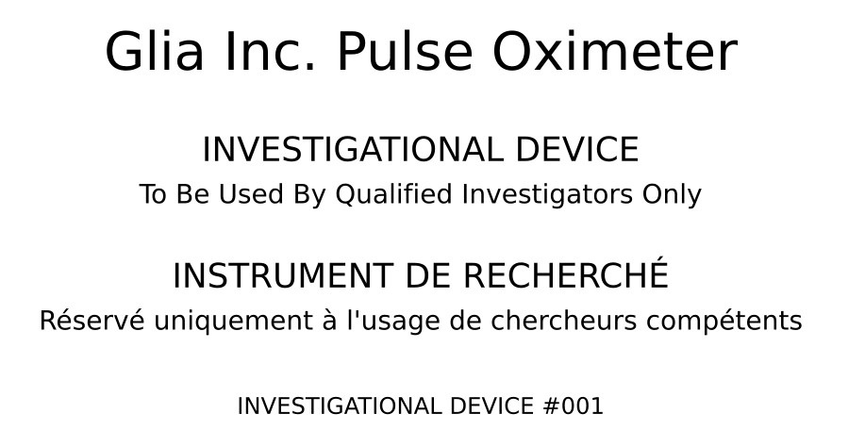Figure 2. Sample device label to be affixed to each device

